MICROSOFT DYNAMICS BC HELPSHEET

Roles, Users and User Setup

This help sheet outlines the essentials for managing Roles, Users and User Setup in Business Central.

Key definitions:
- User – someone who is authorised to sign in to Business Central.
- Role – the profile or view of the system that the user sees, this determines the ‘Role Centre’, which does not change permissions.
- License – Microsoft 365 product license that enables access to Business Central (Premium, Essentials, Team Member, etc.).
- Permission sets – control which tables/pages/actions a user can perform.
- Security groups – manage access at scale by assigning permission sets to groups.

To add a user and enable BC access
- Create account in Microsoft 365 / Entra ID
- Add user in Microsoft 365 Admin Centre. Assign sign-in name and the license that you require this user to have.
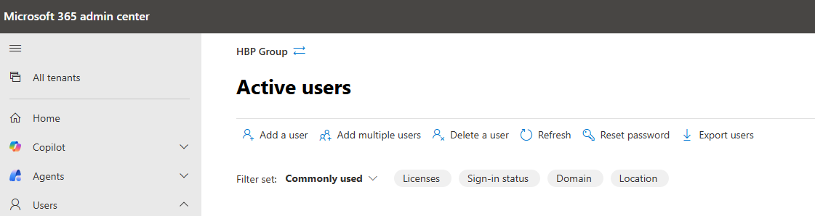
- Sync users into Business Central
- In BC, using the global search function, search for Users.
- Click ‘Update Users from Microsoft 365’ to import the user that you have just created.
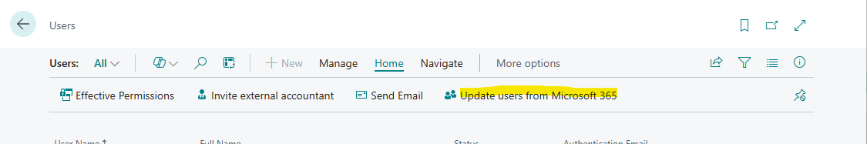
- Verify license and sign in
- Confirm license assigned in Microsoft 365.
- Set up User Card details
- In Users, open the User Card and add all relevant information. When you have done this – ensure top-right of the card shows ‘Saved’ before you close it.
- Ensure to test access.

Permission sets – types, creation and maintenance
Permission set types
- Built-in - delivered and maintained by Microsoft as part of Business Central.
- User-defined - created by yourself, to personalise access within your system.
Create or copy a permission set
- Use the search function to find Permission Sets.
- Choose New to create or Copy existing permission set.
Best practice: Copy Microsoft sets and modify the copy, avoid editing built-in permission sets directly, this is because they may change with updates.

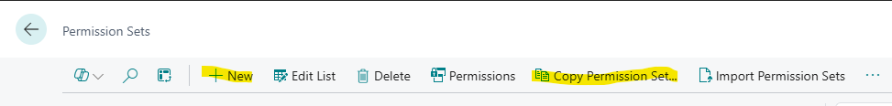

Assign permission sets

Business Central uses permission sets to balance access and data protection. Permission sets define which objects users can access and what they can do with them (read, insert, modify, delete).
Access is controlled by:
- The permission sets assigned to a user
- The type of object (tables, pages, reports, code units, etc.)
- The user’s license, which can further restrict access

This system ensures users only see and work with the data they need—for example, warehouse staff can be restricted from financial data—while still allowing them to perform their roles effectively. User and security management in Business Central is handled through assigning and maintaining these permission sets.

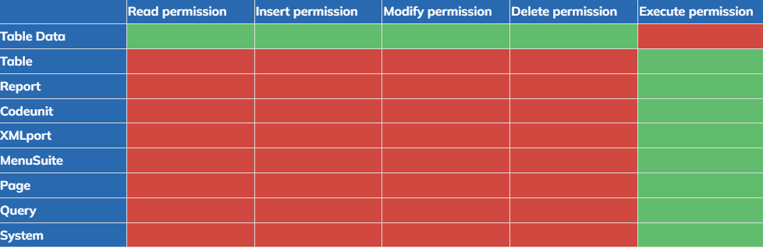

Role Centres

- What is it? A Role Centre, also known as a Profile, defines how the homepage looks, defines specific action/navigation bar menus, and also actions a user sees when they first log in to BC.
- This controls how the system looks, and NOT what the user is permitted to do, this is primarily the layout of the main page.

Some key points to remember:
- Swapping to a different Role Centre does not change any permissions.
- A user can have full permissions but a very limited Role Centre, or vice versa.

Commonly used, built-in Role Centres:
- Business Manager – a rather broad overview, suitable for managers/power users.
- Accountant – finance-focused pages, cues and reports.
- Sales Order Processor – sales quotes, orders, customers.
- Purchasing Agent – vendors, purchase orders, invoicing.
- Warehouse Worker – warehouse activities like inventory handling.
- Team Member – very limited UI aligned to a Team Member license.
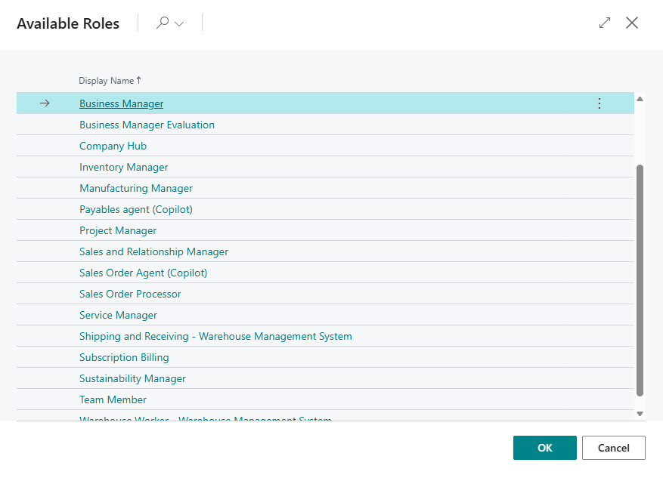

Assigning Roles and Permission Sets to Users

- Assign a Role Centre
- Search for ‘Profiles (Roles)’ in BC.
- Have a look at the profiles that are already available or make a custom one if required.
- Search for ‘User Settings’.
- You will then see a list of all the users you have; the ‘Role’ column shows what Role Centre the user will be automatically assigned to. Note that you can also change Language/Region codes as well as what Company it will put you in.
- NOTE – Role Centres affect appearance of your Business Central, not access/permissions.
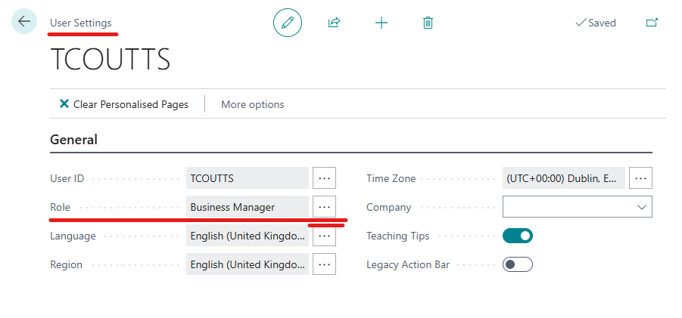

- Assign Permission Sets
- Search for ‘Users’ in BC.
- Select the required User.
- This will open their User Card, beneath the ‘User Permission Sets’ header, you can add the lines for the permission sets required for this user.
- NOTE – Ensure these have saved by ensuring it says the word ‘Saved’ in the top corner of the User Card.

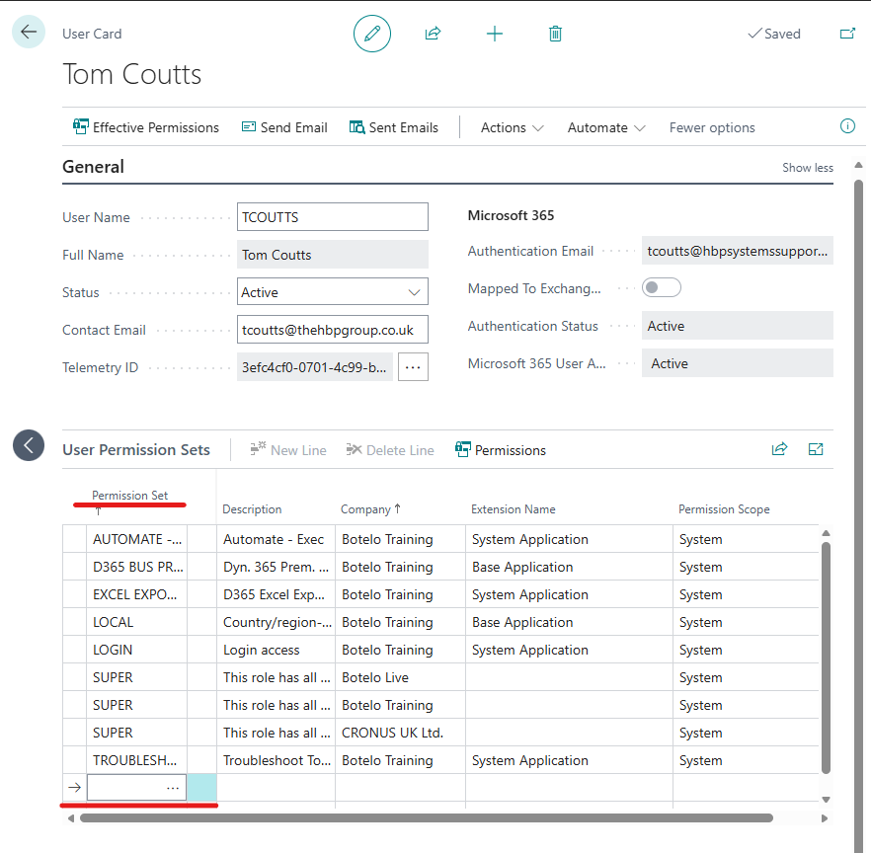

Security Groups

- Definition: A security group is an Entra ID group that is linked to BC and used to manage user permissions in a centralised manor. A security group allows you to assign permission sets to a group instead of individual users. Any user who is a member of that group automatically inherits the group’s permissions in Business Central.
- With and without security groups: Without security groups, every new starter means manual permission setup, mistakes are easy to make, and access becomes inconsistent over time; with security groups, onboarding is faster, errors are reduced, audits are cleaner.
- How security groups work: Create the group in Entra ID, import it into Business Central, assign the required permission sets to the group, and then manage access simply by adding or removing users from that group in Entra ID. Business Central automatically applies or removes permissions based on group membership. It is seen as best practice too remove preset permissions after adding a user to a security group with defined permissions.

Step-by-step instructions on Security Groups

- Create Security Group (Entra ID)
- Go to https://entra.microsoft.com
- Navigate to Groups → All groups → New group
- Set:
  - Group type = Security
  - Name = e.g. BC Finance Users
  - Membership type = Assigned
- Click Create
- Add required users to the group

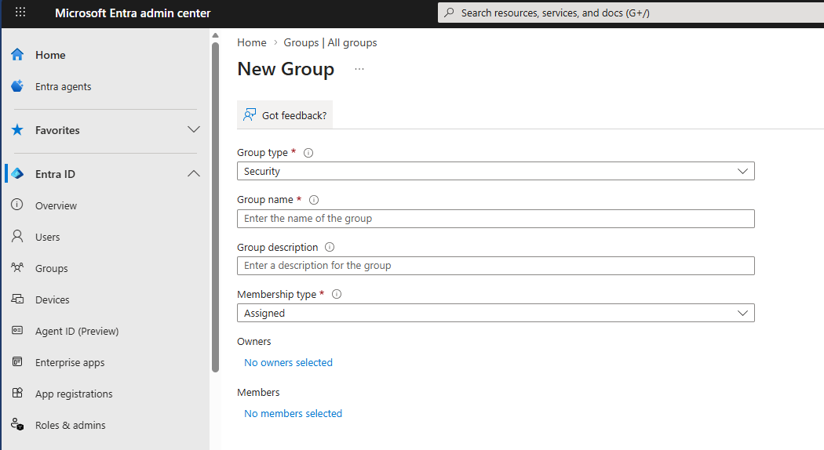

- Add Security Group in Business Central
In BC search for Security Groups
Click New
Select the Entra ID security group
Click OK / Save

- Assign Permission Sets to Group
Open Security Groups page in BC
Select the group (e.g. BC Finance Users)
Click Permission Sets
Click Add
Select required permission sets (e.g. D365 FINANCE, D365 READ)
Close/save

- Sync Users (if needed)
Search Users
Click Update Users from Microsoft Entra ID
Wait for sync to complete

- Verify Access
Open Users
Select the user
Check the following:
  - Security Groups tab shows correct group
  - Effective Permissions confirms access

Onboarding Checklist

- Create M365 account & assign license.
- Create / add to Entra security group (if applicable).
- In BC: Search Users → Update Users from Microsoft 365 (SUPER required).
- Open User Card → populate General info → Save → confirm “Saved”.
- Assign Permission Sets (or add to Security Group) → Save.
- Test sign-in and run role-specific transactions.
- Log setup in Access Register (owner, date, notes).

A Summary

Business Central access is managed by creating a user in Microsoft 365, assigning a licence, and syncing them into BC. What the user sees is controlled by a Role Centre, but what they can do is controlled by permission sets, which define access to data and functions. For easier management, security groups can be used so permissions are assigned to a group instead of individuals, and users automatically inherit the correct access. Once set up, the user is tested to confirm they can sign in and carry out their role.

